**DAILY ONLINE ACTIVITIES SUMMARY**

|  |  |  |  |  |  |  |  |  |
| --- | --- | --- | --- | --- | --- | --- | --- | --- |
| **Date:** | **24-06-2020** | | | | | **Name:** | **Huda Sultana** | |
| **Sem & Sec** | **8 A** | | | | | **USN:** | **4AL16CS039** | |
| **Online Test Summary** | | | | | | | | |
| **Subject** | | **-** | | | | | | |
| **Max. Marks** | | **-** | | **Score** | | | **-** | |
| **Certification Course Summary** | | | | | | | | |
| **Course** | **What is Artificial Intelligence.** | | | | | | | |
| **Certificate Provider** | | | **AWS** | | **Duration** | | | **30 mins** |
| **Coding Challenges** | | | | | | | | |
| **Problem Statement:**   1. **Write a C Program to gcd and lcm using recursion** | | | | | | | | |
| **Status: Solved** | | | | | | | | |
| **Uploaded the report in Github** | | | | | **Yes** | | | |
| **If yes Repository name** | | | | | **Hudasulltana/online_coding** | | | |
| **Uploaded the report in slack** | | | | | **Yes** | | | |

Online Test Details:

Not Conducted

Certification Course Details:

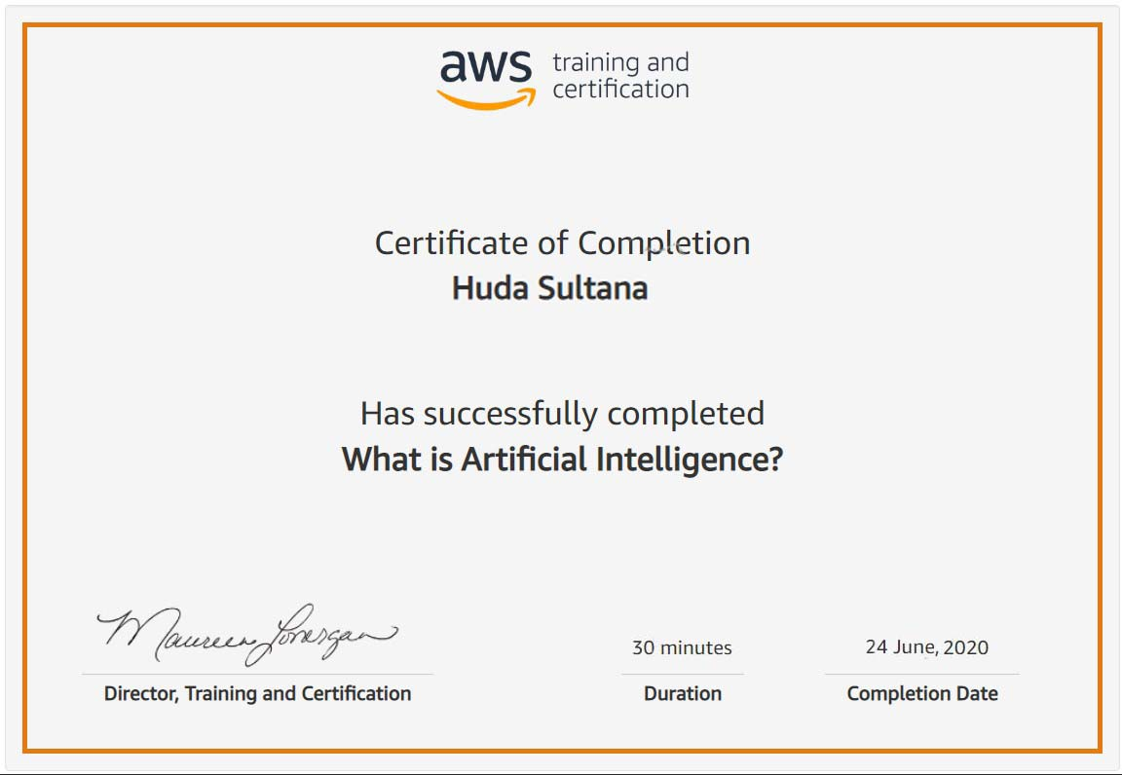

Coding Challenges Details:

**PROGRAM 1 .**

**//gcd and lcm using recursion**

**#include <stdio.h>**

**int gcd(int x, int y);**

**int main()**

**{**

**int num1, num2, hcf, lcm;**

**printf("Enter two integer Values:\n");**

**scanf("%d\n%d", &num1, &num2);**

**printf("%d\n%d\n",num1,num2);**

**hcf = gcd(num1, num2);**

**lcm=(num1*num2)/hcf;**

**printf("GCD of %d and %d is = %d",num1,num2, hcf);**

**printf("\nLCM of %d and %d is = %d",num1,num2,lcm);**

**return 0;**

**}**

**int gcd(int x, int y)**

**{**

**if (y == 0)**

**{**

**return x;**

**}**

**else**

**{**

**return gcd(y, x % y);**

**}**

**}**